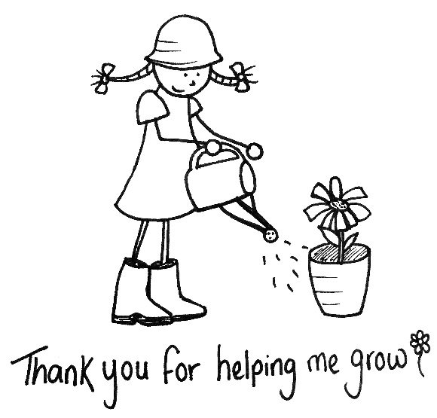

- Brief the staff
The more information you give the staff, the better time your child will have. “Tell them you child’s likes, dislikes, what foods they eat, when they tend to sleep, anything that frightens them etc.
- Share some positive ideas about nursery
Talk about nursery in positive terms, as something exciting and enjoyable.
- Keep on smiling
No matter how torn up you’re feeling about your child taking their first fledgling steps outside the nest, you mustn’t show it to them. If your child sees you crying or fretting, you’ll make them uneasy about the whole nursery experience.
- Don’t keep running back
When it’s time for you to say goodbye, explain carefully that you’re about to go and you’ll be back to pick them up when nursery is over. Don’t start to leave and then get drawn back by tears and a trembling lip.
- Boost both your social lives
Make friends with parents who have children of a similar age outside of the setting. Keep an eye out on day one and don’t be shy about introducing yourself to other parents/guardians.
- Allow a comforter
“If your child has a favourite toy or blankie they want to take with them to help them settle in, it doesn’t hurt at first”. Lots of parents even bring along a child’s special cup/sleeping blanket to make nursery feel like a home from home.
- How does your child self soothe?
Let your child’s keyworker know how your child self-soothes.

